1.INTRODUCTION
1.1 Project Overview:
The Family Expense Management System using ServiceNow is developed to help families record, track, and analyze their daily financial activities in a simple and organized way. In many households, expenses are usually written in notebooks or calculated manually, which makes it difficult to know the total spending, monthly budget, and remaining savings. To overcome this problem, this system provides a digital platform where users can enter their income and different types of expenses such as food, travel, bills, education, and medical costs through easy-to-use forms. All the data is stored in ServiceNow tables, and the system automatically calculates the total income, total expenses, and remaining balance using Business Rules and server-side scripts. It also categorizes expenses so that users can clearly understand where most of the money is being spent. The application includes a dashboard that displays real-time financial information with charts and reports, such as monthly expense summaries and category-wise spending patterns. Role-based access control ensures that only authorized users can add or view financial records, providing data security. This system reduces manual calculations, avoids errors, improves financial planning, and helps families control overspending and increase savings. Overall, it is a simple, automated, and efficient solution for managing household finances using the ServiceNow platform.
1.2 Purpose:
The main purpose of the Family Expense Management System using ServiceNow is to provide a simple and centralized platform for families to record, monitor, and manage their daily income and expenses in an organized and automated way. Many families face difficulty in tracking where their money is being spent because they rely on manual methods like notebooks or memory, which often leads to calculation errors and poor budget planning. This project aims to eliminate those problems by allowing users to enter their financial details through structured forms, automatically calculate total expenses and remaining balance, and generate clear reports and dashboards for better understanding of spending patterns. By categorizing expenses and showing monthly summaries, the system helps families identify unnecessary spending, plan their budgets effectively, and improve their savings. It also ensures secure data storage and role-based access so that only authorized users can manage financial records. Overall, the purpose of this project is to make household financial management easier, more accurate, and more efficient through automation and visualization on the ServiceNow platform.

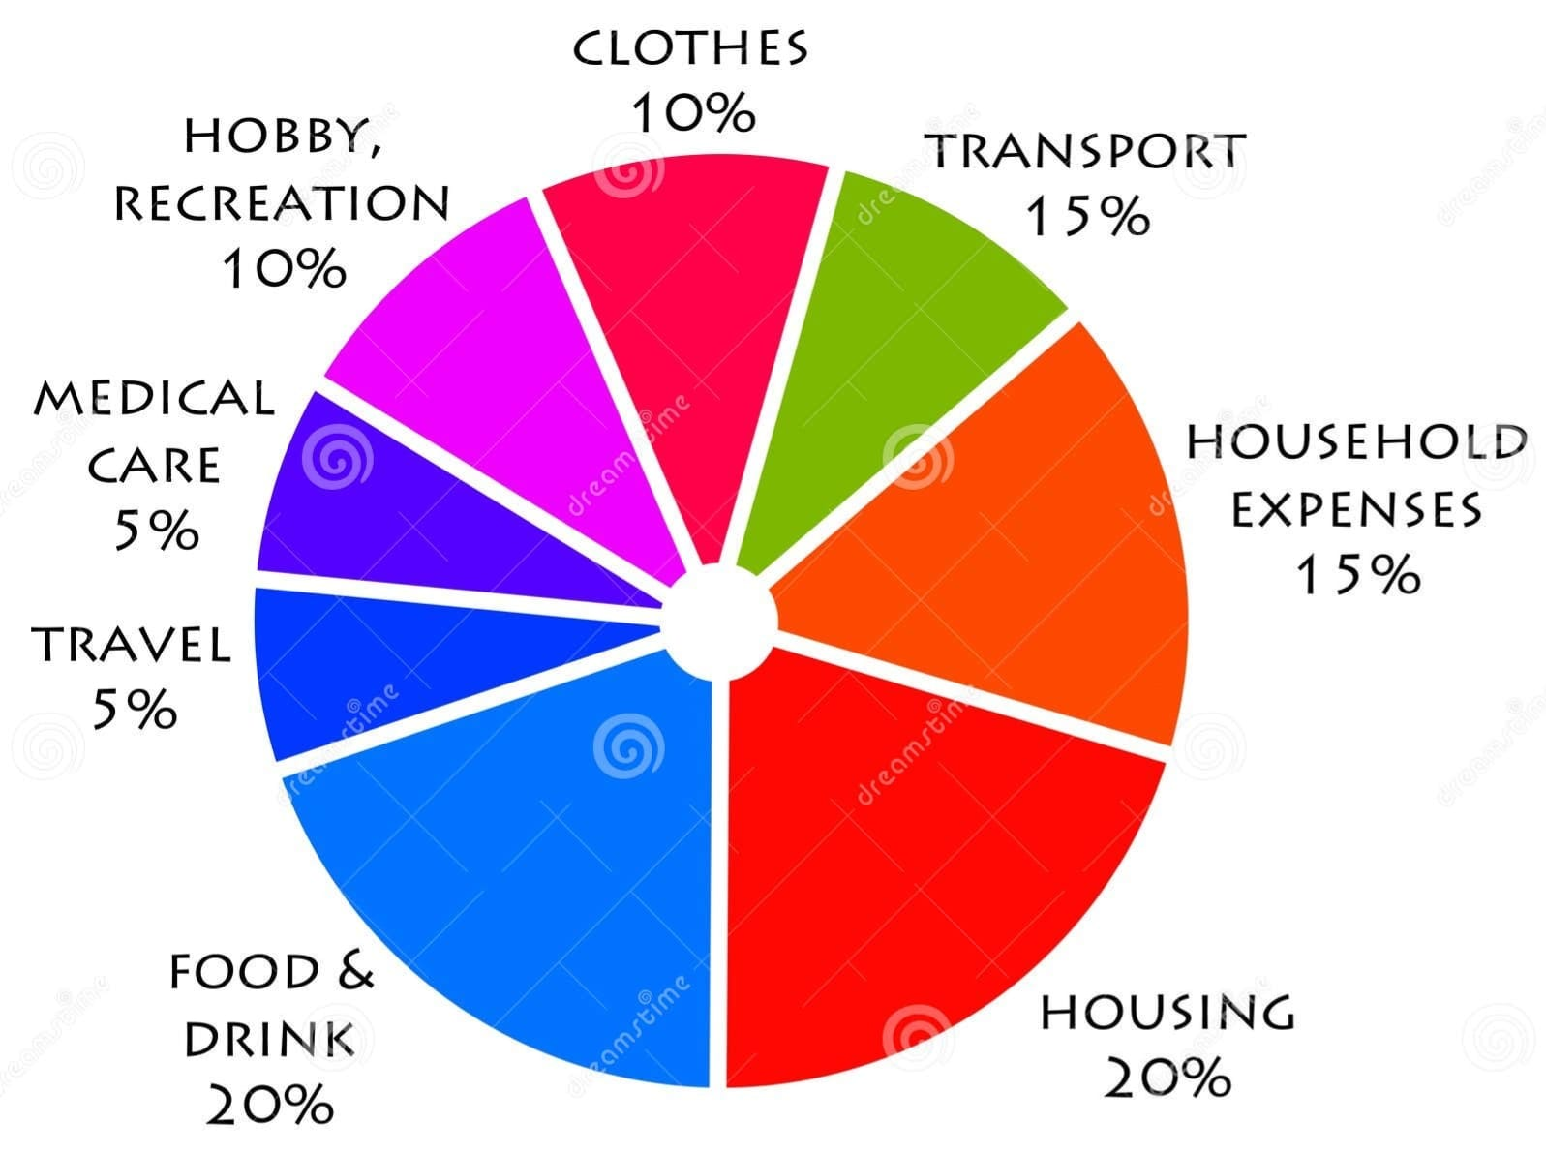

Based on the given expense distribution chart, the family’s monthly spending is divided into different essential and non-essential categories, which helps in understanding financial priorities and planning a proper budget. The largest portion of the income, 20%, is spent on food and drink, indicating that daily consumption is the major expense in the household. Housing also takes 20%, which includes rent, maintenance, electricity, and other basic living costs, showing that accommodation is a fixed and unavoidable expense. Household expenses and transport each account for 15%, which covers groceries, utility items, and travel costs such as fuel or public transport. Clothes and hobby or recreation each take 10%, representing lifestyle and personal spending that can be controlled if savings are needed. Travel and medical care are the lowest at 5% each, which may vary depending on emergencies or seasonal needs. This type of category-wise visualization is very useful in the ServiceNow family expense management system because it allows users to clearly see where most of the money is being spent, identify high-cost areas like food and housing, and reduce non-essential expenses such as recreation to improve savings. It also helps in generating dashboards and reports for better financial decision-making and monthly budget planning.

2. IDEATION PHASE
2.1 Problem Statement
Customer Problem Statement Template:
Create a problem statement to understand your customer's point of view. The Customer Problem Statement template helps you focus on what matters to create experiences people will love.
A well-articulated customer problem statement allows you and your team to find the ideal solution for the challenges your customers face. Throughout the process, you’ll also be able to empathize with your customers, which helps you better understand how they perceive your product or service.
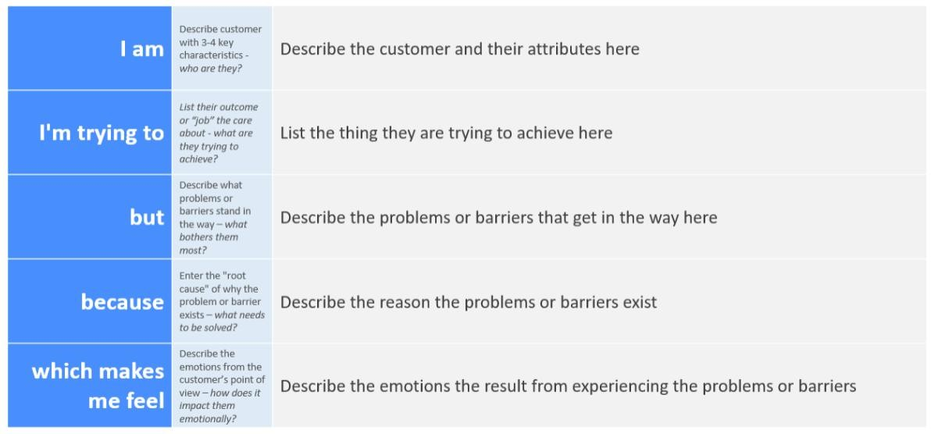
Reference: https://miro.com/templates/customer-problem-statement/ Example:

Customer Problem Statements – Calculating family expenses using service now
Parameter | Problem Statement PS-1 | Problem Statement PS-2
I am (Customer) | A salaried person managing monthly household expenses | A homemaker tracking daily spending and savings
I’m trying to | Calculate total family expenses and stay within my monthly budget | Record daily expenses and identify where money is being spent most
But | I use manual notes or Excel, which is time-consuming and error-prone | I forget to track small expenses and cannot generate monthly reports
Because | There is no automated system to categorize expenses and show real-time totals | I don’t have a simple tool that gives alerts when spending exceeds the budget
Which makes me feel | Stressed and unsure about my financial planning | Confused about savings and unable to control unnecessary expenses

2.2 Empathy Map Canvas:
An empathy map is a simple, easy-to-digest visual that captures knowledge about a user’s behaviours and attitudes.
It is a useful tool to helps teams better understand their users.
Creating an effective solution requires understanding the true problem and the person who is experiencing it. The exercise of creating the map helps participants consider things from the user’s perspective along with his or her goals and challenges.
Example:
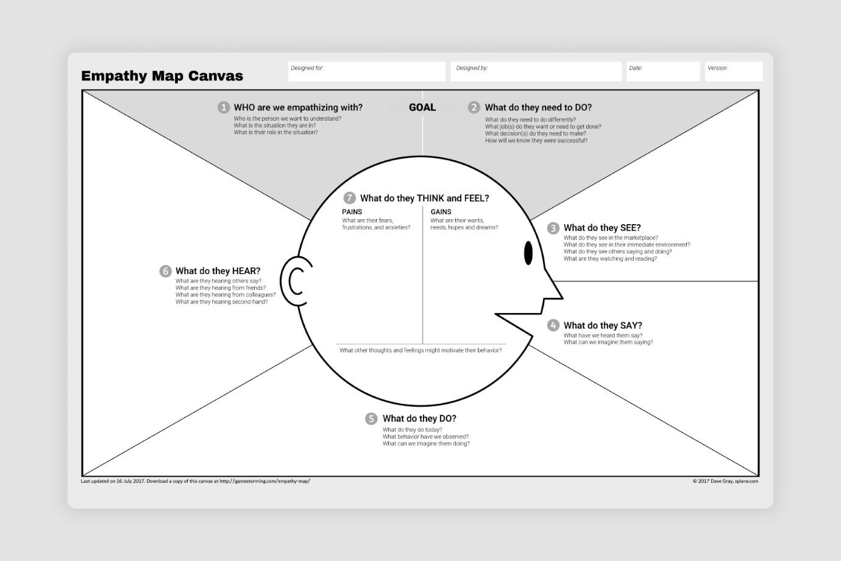
2.3 Brainstorming
Brainstorm & Idea Prioritization Template:
Brainstorming provides a free and open environment that encourages everyone within a team to participate in the creative thinking process that leads to problem solving. Prioritizing volume over value, out-of-the-box ideas are welcome and built upon, and all participants are encouraged to collaborate, helping each other develop a rich amount of creative solutions.
Use this template in your own brainstorming sessions so your team can unleash their imagination and start shaping concepts even if you're not sitting in the same room.
Reference: https://www.mural.co/templates/brainstorm-and-idea-prioritization Step-1: Team Gathering, Collaboration and Select the Problem Statement

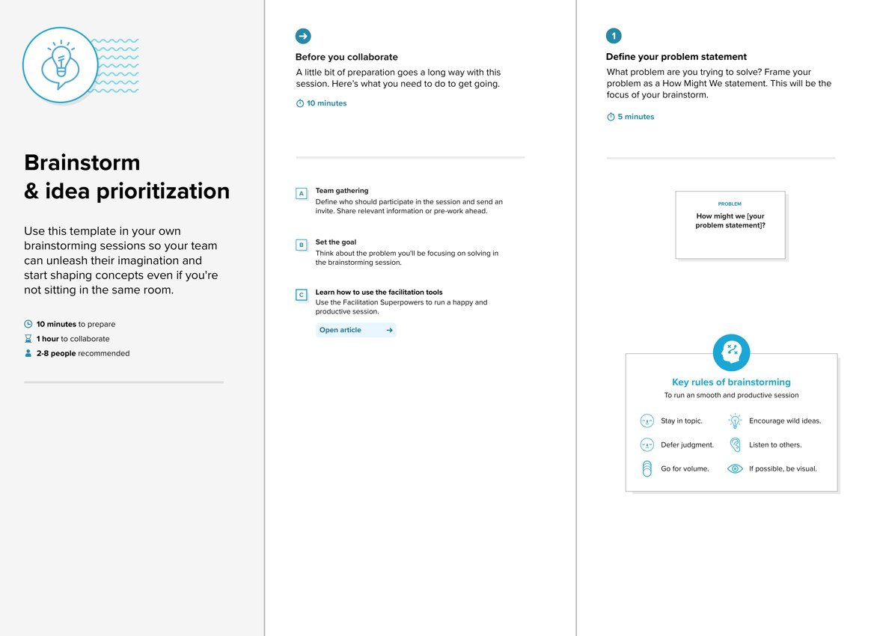

Step-2: Brainstorm, Idea Listing and Grouping
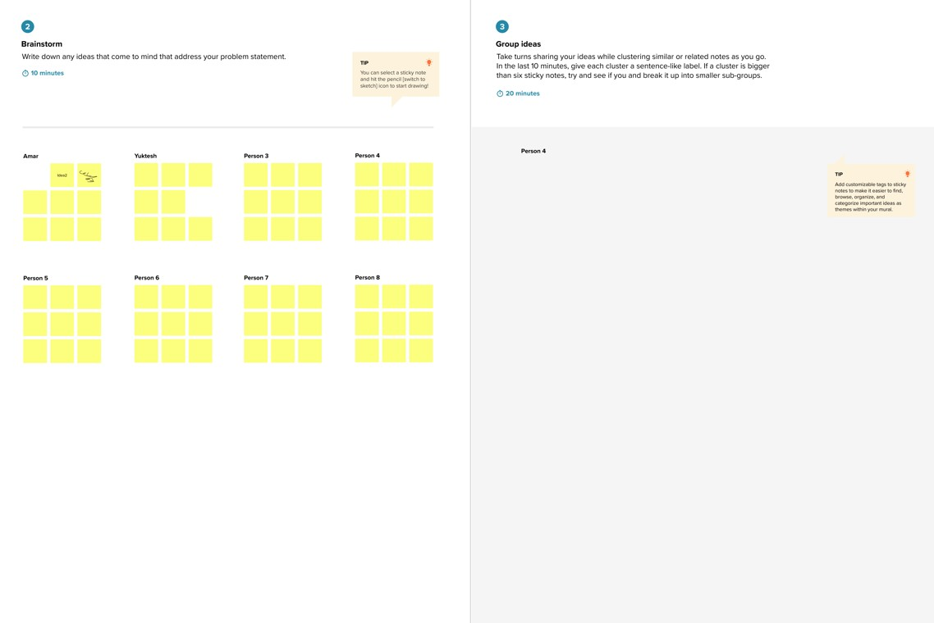
Step-3: Idea Prioritization
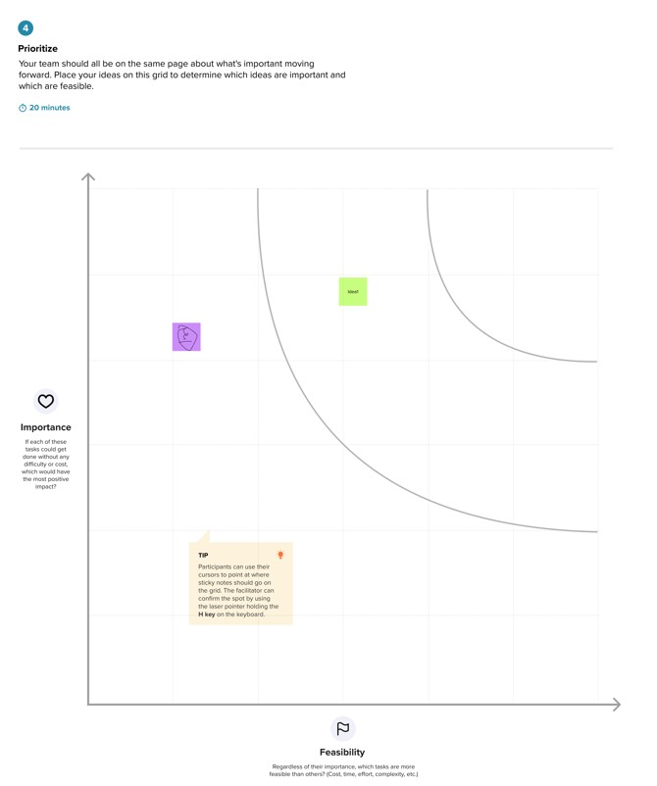

3. REQUIREMENT ANALYSIS
3.1 Customer Journey map


3.2 Solution Requirment
Functional Requirements:
Project team shall fill the following information in the proposed solution template.
S.No. | Parameter | Description
1. | Problem Statement | Difficulty in tracking fragmented family spending across multiple members and categories manually.
2. | Idea / Solution description | A centralized ServiceNow custom application using automated workflows and dashboards to track household finances.
3. | Novelty / Uniqueness | Leverages enterprise-grade automation (ServiceNow Flow Designer) for personal financial management and real-time alerts.
4. | Social Impact / Customer Satisfaction | Promotes financial literacy and discipline within the family through transparent and easy-to-read reporting.
5. | Business Model | A personal utility app; could be scaled as a "Productized Service" for ServiceNow developers' families.
6. | Scalability of the Solution | Can be expanded to include investment tracking, multi-currency support, and automated bank statement imports.
3.3 Data Flow Diagram (DFD):
Data Flow Diagrams:
A Data Flow Diagram (DFD) is a traditional visual representation of the information flows within a system. A neat and clear DFD can depict the right amount of the system requirement graphically. It shows how data enters and leaves the system, what changes the information, and where data is stored.
Example: (Simplified)
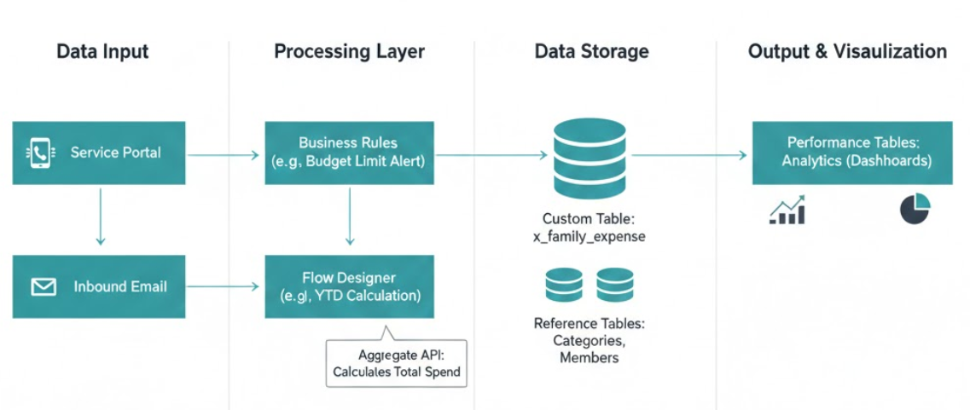

3.4 Technology Stack:
Technical Architecture: The Deliverable shall include the architectural diagram as below and the information as per the table1 & table 2
Example: Order processing during pandemics for offline mode

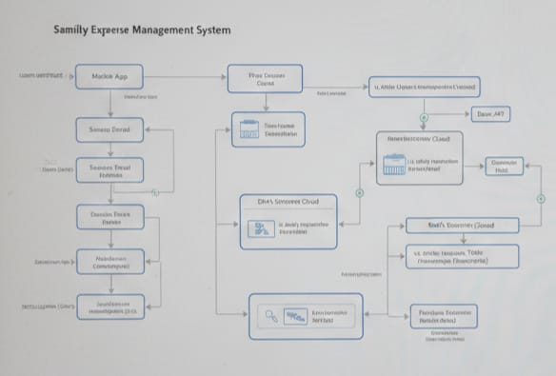
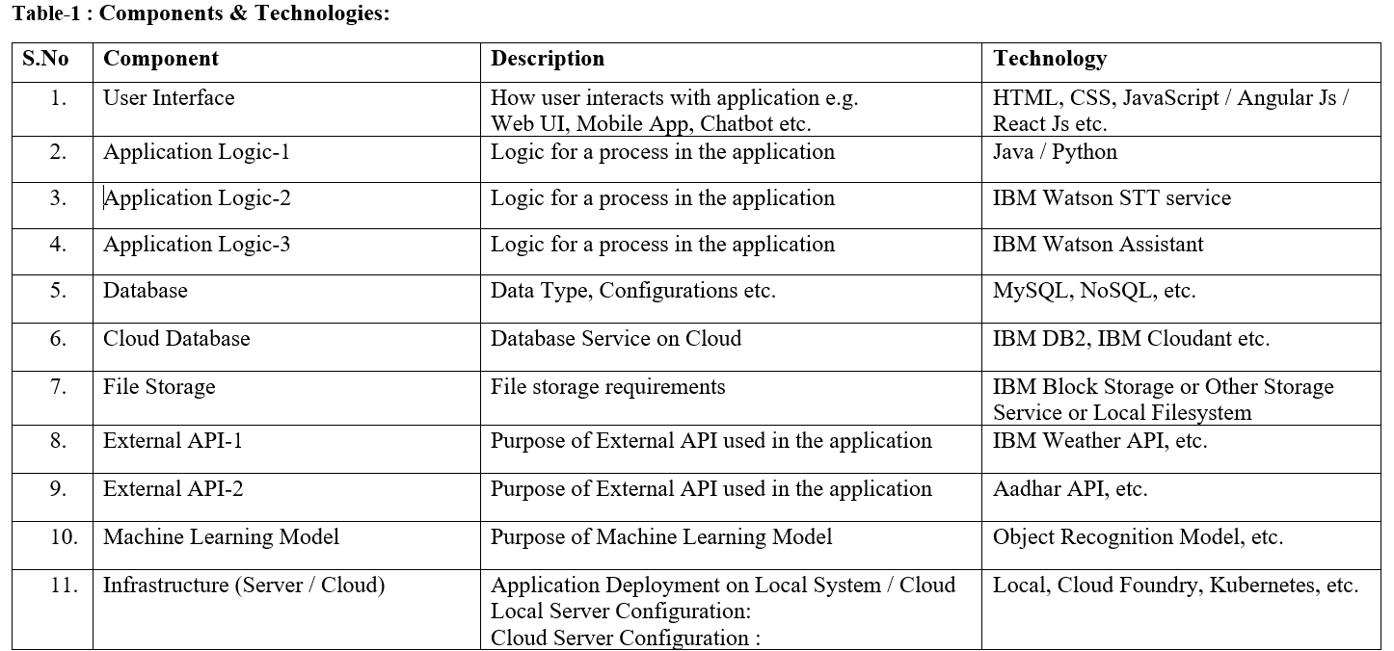

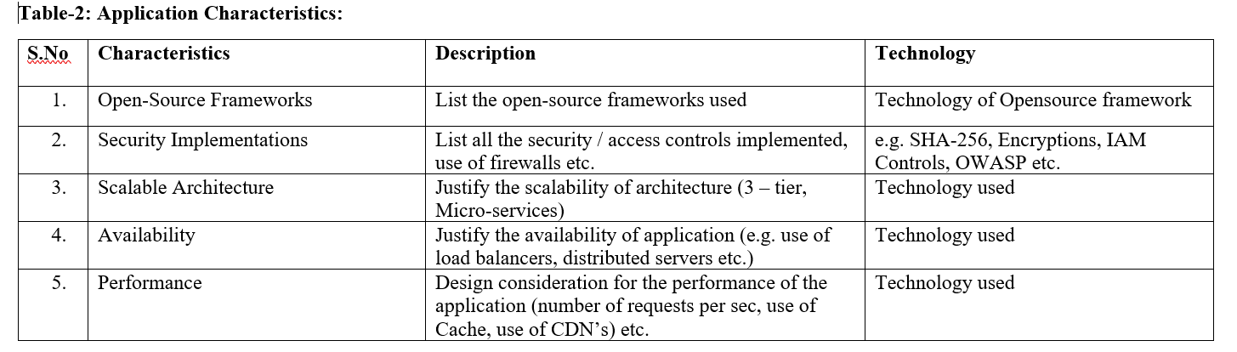

4. PROJECT DESIGN

4.1 Problem Solution Fit
Problem – Solution Fit Template:
The Problem-Solution Fit simply means that you have found a problem with your customer and that the solution you have realized for it actually solves the customer’s problem. It helps entrepreneurs, marketers and corporate innovators identify behavioral patterns and recognize what would work and why
Purpose:
- Solve complex problems in a way that fits the state of your customers.
- Succeed faster and increase your solution adoption by tapping into existing mediums and channels of behavior.
- Sharpen your communication and marketing strategy with the right triggers and messaging.
- Increase touch-points with your company by finding the right problem-behavior fit and building trust by solving frequent annoyances, or urgent or costly problems.
- Understand the existing situation in order to improve it for your target group.
Template:
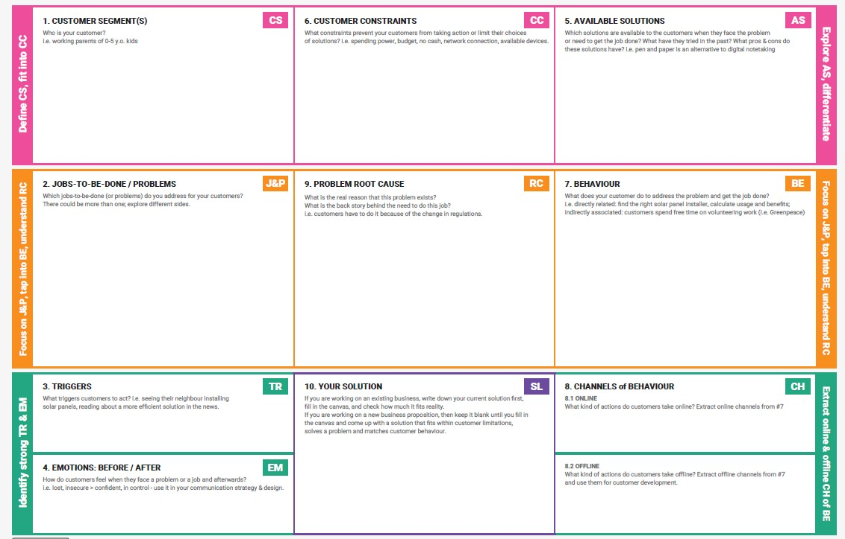
References:
- https://www.ideahackers.network/problem-solution-fit-canvas/
- https://medium.com/@epicantus/problem-solution-fit-canvas-aa3dd59cb4fe
  - Proposed Solution:
S.No. | Parameter | Description
1 | Problem Statement | Many families manage their daily expenses manually using notebooks or memory, which leads to calculation errors, lack of expense tracking, and difficulty in planning monthly budgets and savings. There is no proper system to categorize expenses, calculate total spending, or analyze financial patterns. Hence, a digital solution is required to record income and expenses, automatically calculate totals, and provide clear financial insights.
2 | Idea / Solution Description | The Family Expense Management System is developed on the ServiceNow platform to help users: – Add and manage income and daily expenses – Categorize expenses such as food, travel, bills, medical, etc. – Automatically calculate total income, total expenses, and remaining balance – Generate monthly and category-wise reports – View dashboards with charts for financial analysis – Maintain secure and centralized financial records.
3 | Novelty / Uniqueness | – Implemented using ServiceNow low-code platform – Automated calculations using Business Rules and Script Includes – Real-time dashboards for expense visualization – Role-based access control for secure financial data – Category-wise expense tracking for better budget planning – Easy-to-use digital forms replacing manual bookkeeping.
4 | Social Impact / Customer Satisfaction | – Helps families control overspending and improve savings – Provides clear visibility of where money is spent – Reduces manual calculation errors – Encourages financial discipline and budget planning – Useful for middle-class families to manage monthly income effectively – Saves time and provides quick financial summaries.
5 | Business Model (Revenue Model) | – Freemium model: Basic expense tracking is free; premium features include advanced reports and budget alerts – Subscription model for multiple family accounts – Integration services for small financial consultants – Custom dashboard solutions for households and small groups.
6 | Scalability of the Solution | – Can be deployed for multiple families using ServiceNow user roles – Modular structure allows adding features like budget alerts, savings goals, and mobile access – Can integrate with banking APIs for automatic transaction tracking – Supports cloud-based data storage and real-time reporting – Scalable dashboards for monthly and yearly financial analysis.

4.3 Solution Architecture:
Solution Architecture: calculating family expenses using service now
Solution architecture in the Family Expense Management System bridges the gap between traditional manual expense tracking and a digital, automated financial management platform. It defines the overall structure and components required to build a system that can record income, store expenses, perform automatic calculations, and generate financial reports and dashboards.
The architecture explains how data flows from user input forms to ServiceNow tables, how Business Rules perform calculations, and how dashboards display the results for better financial planning.
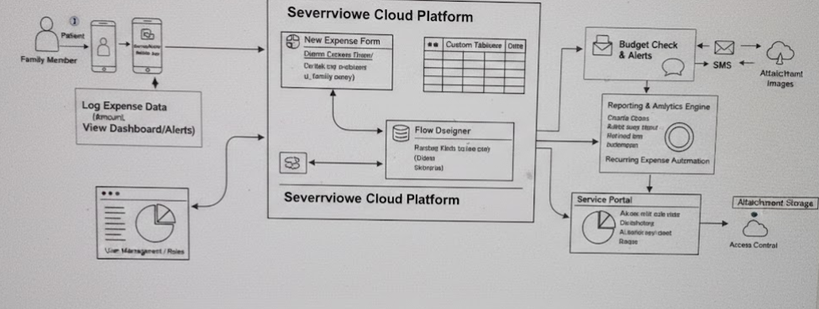

Figure 1: Architecture and data flow of the voice patient diary sample application
- Reference: https://aws.amazon.com/blogs/industries/voice-applications-in-clinicalresearch-powered-by-ai-on-aws-part-1-architecture-and-design-considerations/

5.PROJECT PLANNING & SCHEDULING
5.1 Project Planning
Product Backlog, Sprint Schedule, and Estimation (4 Marks)

The planning phase of the Family Expense Management System focuses on identifying the problem, defining the project scope, selecting the required tools, and organizing the development process. Initially, the need for a digital solution to replace manual expense tracking was analyzed, and the key objectives such as recording income, managing daily expenses, automatic calculation of totals, and generating financial reports were defined. The ServiceNow platform was chosen because it provides built-in support for tables, forms, Business Rules, dashboards, and role-based security, which are essential for developing a financial tracking system. During the planning stage, the system modules were divided into income management, expense entry, calculation logic, report generation, and dashboard visualization. The database structure, including income and expense tables with necessary fields, was designed. User roles such as admin and family member were also planned to ensure secure access. A step-by-step development approach was prepared, starting from table creation, form design, and script implementation to dashboard configuration and testing. This planning phase ensured that the project was developed in an organized manner, met all functional requirements, and provided a scalable foundation for future enhancements like budget alerts and savings tracking.
Use the below template to create product backlog and sprint schedule
Sprint | Functional Requirement (Epic) | User Story Number | User Story / Task | Story Points | Priority
Sprint-1 | Registration | USN-1 | As a user, I can register via email and password. | 2 | High
Sprint-1 | Registration | USN-2 | As a user, I receive a confirmation email after registering. | 1 | High
Sprint-1 | Expense Tracking | USN-3 | As a user, I can log a new expense entry. | 3 | High
Sprint-2 | Reporting | USN-4 | As a user, I can view a pie chart of my spending categories. | 2 | Medium
Sprint-2 | Dashboard | USN-5 | As a user, I can see a full financial dashboard of my budget. | 5 | High

Project Tracker, Velocity & Burndown Chart: (4 Marks)
Sprint | Total Story Points | Duration | Sprint Start Date | Sprint End Date (Planned) | Story Points Completed | Sprint Release Date (Actual)
Sprint-1 | 20 | 10 Days | 02 Mar 2026 | 13 Mar 2026 | 20 | 13 Mar 2026
Sprint-2 | 20 | 10 Days | 16 Mar 2026 | 27 Mar 2026
Sprint-3 | 20 | 10 Days | 30 Mar 2026 | 10 Apr 2026
Sprint-4 | 20 | 10 Days | 13 Apr 2026 | 24 Apr 2026

A Sprint fixed period or duration in which a team works to complete a set of tasks
An Epic is a big task or project that is too large to complete in one sprint. It is broken down into smaller tasks (stories) that can be completed over multiple sprints.
A Story is a small task . It is part of an Epic.
A Story Point is a number that represents how much effort a story takes to complete. (usually in form of Fibonacci series)
- Very Easy task
- Normal task
- Moderate task
- Difficult task
Storypoint -5 (1,2,3,5)
Sprint 1
Data Collection (Epic 1)
Gathering Data (USN1) 2
Loading Data(USN2) 1
Data Preparation (Epic 2)
Handling Missing Values(USN3) 3
Creating Fields(USN4)3
Handling Inconsistency in Data(USN5)3
Total Story Point in Sprint 1= 2+1+3+3+3=12
Sprint 2
Data Visualization (Epic 3)
Bar Chart(USN6) 2
Pie Chart(USN7) 2
Line Chart(USN8) 2
Map(USN9) 4
Dashboard (Epic 4)
Developing Dashboard(USN10) 5
Story (Epic 5)
Developing Story(USN11)
Total story Point in Sprint 2= 2+2+2+4+5+5=20

Total Story Points
Sprint 1 = 12
Sprint 2 = 20

Velocity= Total Story Points Completed​/ Number of Sprints
Total story Points= 12+20=32
No of Sprints= 2
Velocity =32/2
16(Story Points per Sprint)
Your team’s velocity is 16 Story Points per Sprint.

6.FUNCTIONAL AND PERFORMANCE TESTING
6.1 Performance Testing
Functional Requirements:
The functional requirements of the Family Expense Management System define the core features that the system must perform to help users manage their household finances effectively. The system should allow users to securely log in and access the application based on their roles, such as admin or family member. It must provide forms to add, edit, and delete income and daily expense records with proper categories like food, travel, bills, and medical. The application should automatically calculate the total income, total expenses, and the remaining balance whenever a new entry is added. It must generate monthly and category-wise reports to help users understand their spending patterns. A dashboard should display real-time financial data using charts and summaries for better visualization. Additionally, the system should allow the admin to manage expense categories and view all records. These functional requirements ensure that the system performs all necessary operations for accurate expense tracking, financial analysis, and effective budget planning.

FR No. | Functional Requirement (Epic) | Sub Requirement (Story / Sub-Task)
FR-1 | User Login & Access | Login through ServiceNow user account Role-based access (Admin / Family Member)
FR-2 | Income Management | Add income through form Edit or delete income records View income history
FR-3 | Expense Entry | Add daily expenses through form Select expense category (Food, Travel, Bills, Medical, etc.) Edit or delete expense records
FR-4 | Expense Calculation | Automatic calculation of total expenses Monthly expense calculation Category-wise expense total
FR-5 | Balance Calculation | Automatic calculation of remaining balance (Income – Expenses) Real-time update after each entry
FR-6 | Reports Generation | Monthly expense report Category-wise expense report Income vs Expense summary
FR-7 | Dashboard Visualization | View total income, total expenses, and balance Pie chart for category-wise expenses Bar chart for monthly spending trends
FR-8 | Admin Management | Manage expense categories View all users’ financial data Configure dashboard and reports

Non-functional Requirements:
The non-functional requirements of the Family Expense Management System describe the quality attributes that ensure the system works efficiently, securely, and reliably. The application must have a simple and user-friendly interface so that all family members, including non-technical users, can easily enter income and expenses without confusion. It should provide secure access through role-based login to protect sensitive financial data from unauthorized users. The system must perform calculations quickly and display dashboards and reports with minimal delay. It should be reliable and provide accurate totals even when multiple records are added or updated.
NFR No. | Non-Functional Requirement | Description
NFR-1 | Usability | The system interface must be simple and user-friendly so that all family members, including non-technical users, can easily add income, record expenses, and view reports.
NFR-2 | Security | The system must provide secure login, role-based access control (Admin and Family Member), and protect financial data from unauthorized access.
NFR-3 | Reliability | The system must accurately calculate total income, total expenses, and balance without errors and function correctly even when multiple records are added.
NFR-4 | Performance | Expense calculations, form submissions, and dashboard reports must load quickly with minimal delay.
NFR-5 | Availability | The application should be available whenever users need to enter expenses or view reports, with minimal downtime on the ServiceNow platform.
NFR-6 | Scalability | The system should support multiple users, large numbers of expense records, and future features like budget alerts and savings tracking without performance issues.

7.RESULTS
7.1 OUTPUT SCREENSHOTS

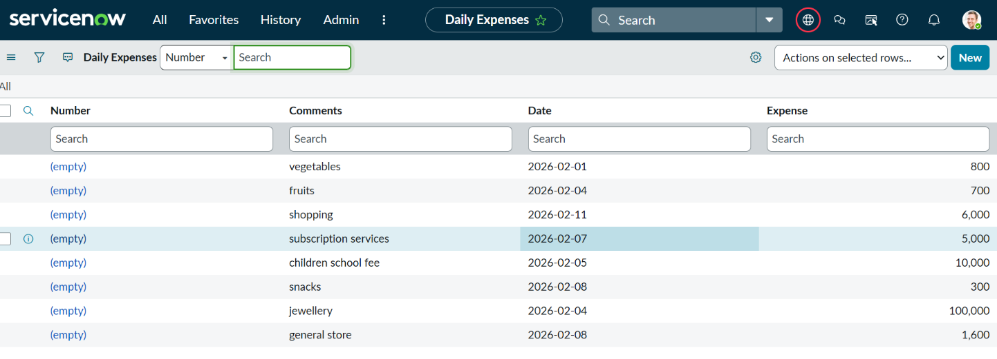

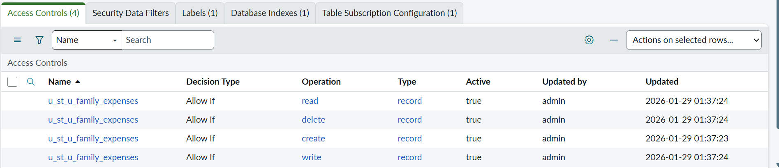

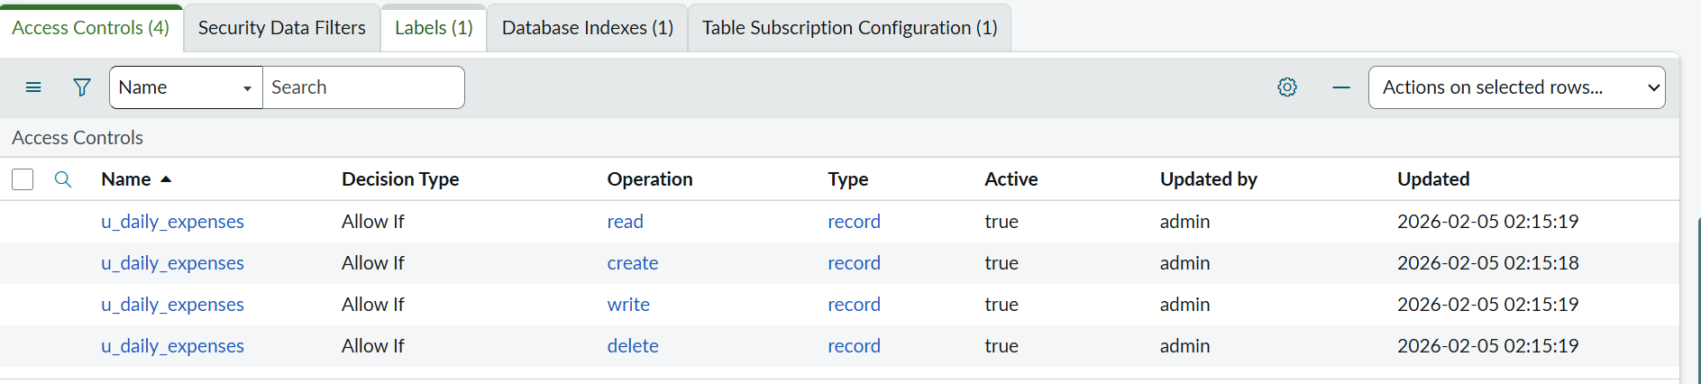

8. ADVANTAGES & DISADVANTAGES

Advantages of Family Expense Management System

- Provides automatic calculation of total income, total expenses, and remaining balance, reducing manual work.
- Helps families track daily spending and identify where most of the money is being used.
- Generates visual dashboards and reports for better financial planning and budgeting.
- Stores all financial records in a centralized and secure platform.
- Role-based access control ensures that only authorized users can view or manage financial data.

Disadvantages of Family Expense Management System

- Requires basic knowledge of the ServiceNow platform for setup and customization.
- Depends on internet access to enter and view financial records.
- Initial configuration of tables, Business Rules, and dashboards may take time.
- If users forget to enter daily expenses, reports may not show accurate financial data.
- Advanced features like bank integration or budget alerts are not available in the basic version.

9. CONCLUSION
The Family Expense Management System using ServiceNow provides a simple, efficient, and automated solution for managing household finances. It replaces manual expense tracking methods with a centralized digital platform where users can record income, add daily expenses, and automatically calculate total spending and remaining balance. By using ServiceNow tables, forms, Business Rules, and dashboards, the system ensures accurate calculations, secure data storage, and real-time financial reporting. The category-wise analysis and visual charts help families clearly understand their spending patterns, control unnecessary expenses, and plan their monthly budget effectively. Overall, this project improves financial discipline, reduces calculation errors, saves time, and supports better decision-making for increasing savings. It also provides a scalable foundation for future enhancements such as budget alerts, savings goals, and mobile access, making it a practical and user-friendly solution for modern household financial management.

10.FUTURE SCOPE
Future Enhancements
- Bank Account Integration:
The system can be integrated with bank APIs to automatically import transactions and categorize expenses without manual entry.
- Multilingual Support:
The application can support multiple regional languages so that all family members can easily use the system.
- Mobile Access:
A mobile-friendly ServiceNow portal or mobile app can be developed to allow users to record expenses anytime and anywhere.
- Budget Alerts and Notifications:
The system can send alerts when expenses exceed the predefined monthly budget or when savings fall below a certain limit.
- Savings Goal Tracking:
Users can set monthly or yearly savings targets, and the system can track progress and provide recommendations.
- Voice-Based Expense Entry:
Voice input can be added to allow users to record expenses without typing, improving accessibility.
- AI-Based Expense Prediction:
Future versions can analyze past spending patterns and predict upcoming expenses to help in better financial planning.

11. APPENDIX

(function executeRule(current, previous /*null when async*/)

{

var FamilyExpenses = new GlideRecord('u_family_expenses');

FamilyExpenses.addQuery('u_date',current.u_date);

FamilyExpenses.query();

if(FamilyExpenses.next()){

FamilyExpenses.u_amount += current.u_expense;

FamilyExpenses.u_expense_details += ">"+current.u_comments+":"+"Rs."+current.u_expense+"/-";

FamilyExpenses.update();

}

else

{

var NewFamilyExpenses = new GlideRecord('u_family_expenses');

NewFamilyExpenses.u_date = current.u_date;

NewFamilyExpenses.u_amount = current.u_expense;

NewFamilyExpenses.u_expense_details += ">"+current.u_comments+":"+"Rs."+current.u_expense+"/-";

NewFamilyExpenses.insert();

}})(current, previous);
Configure Realtionship:
(function refineQuery(current, parent) {
// Add your code here, such as current.addQuery(field, value);
current.addQuery('u_date',parent.u_date);
current.query();
})(current, parent);

GitHub link: https://github.com/sree4377sree/Calculating-family-expenses

Demo link: https://drive.google.com/file/d/1DiMr6-XVSVD3Dce03oM93nY-xelo6lfo/view?usp=drive_link

